**Assignment 2**

**Question 1**

**Write a Python program to print even numbers in a list.**

**Sample:**

**Input: list1 = [12, 3, 55, 6, 144]**

**Output: [12, 6, 144]**

**Input: list2 = [2, 10, 9, 37]**

**Output: [2, 10]**

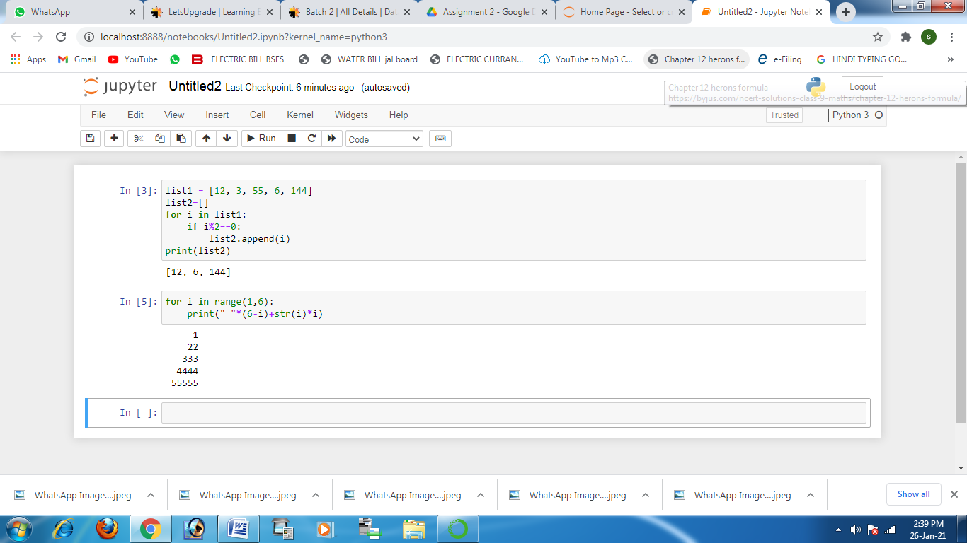

**Question 2**

**Write a program to print the following pattern**

**1**

**22**

**333**

**4444**

**55555**

